# **Thaloria Legacy Game Document**

# **PRU212 - Group 5**

| SE173039 | Phạm Nguyễn Trọng Tuấn | 22% |
| --- | --- | --- |
| SE183124 | Phạm Xuân Hoàng | 24% |
| SE183870 | Ngô Lê Thảo Nguyên | 18% |
| SE183122 | Lê Đặng Minh Trí | 20% |
| SE170585 | Phạm Bích Ngọc | 16% |

## **1. Game Overview**

### **Game: Thaloria Legacy**

### **Summary:**

* **Genre:** **2D Top-Down Adventure**
* **Features:**
  + Explore an open world with many mysterious lands.
  + Gentle combat mechanics, focusing on puzzles & survival.
  + A compelling and dramatic storyline
* **Platform:** **Windows**
* **Target Players:** **Casual & Hardcore Adventure Fans**

### **Story & World Settings:** Thaloria was once a glorious kingdom, but now it lies in ruins. Drakthor the Eternal Dragon, an immortal beast, has awakened from his millennia-long slumber in Infernal Hollow, a cavern buried deep within a colossal volcano. With a burning ambition to incinerate the world and establish a dragon empire, Drakthor has unleashed the Four Harbingers of Doom, ancient entities wielding destructive power:

* **Final Protocol Terminal, the AI Tyrant** – A machine from the future, summoned by Drakthor to eradicate all life. → **ProtoCore**
* **Gaian, the Stone Colossus** – A massive giant of stone, shaking the earth with every step. → **Titan’s Remnant**
* **Amun-Ra, the Pharaoh of the Cursed** – A mummified pharaoh, raising an army of the undead. → **Pharaoh’s Relic**
* **Cryon, the Frost Reaper** – A frozen warrior, capable of encasing all life in ice. → **Everfrost**

Under their might, Thaloria has descended into chaos. Yet, one hero—the last warrior of a fallen kingdom—still stands. Embarking on a perilous journey, he must defeat each Harbinger and collect the Primal Soul Fragments, remnants of an ancient god who once sealed Drakthor away.

### **Game Objectives**

* Defeat each of the **Four Harbingers of Doom** and collect the **Primal Soul Fragments**.
* Once all four fragments are gathered, journey to **Infernal Hollow**, Drakthor’s lair.
* Face **Drakthor the Eternal Dragon** in the ultimate showdown.
* Restore the **Primal Soul**, seal Drakthor away forever, and save the world.

### **Art Style:**

* **Graphics Style:** **Pixel Art**
* **Primary Color Palette:**
  + **Dark & mysterious tones** for cursed and forsaken areas.
  + Strong contrast between light and shadow to enhance the sense of adventure and mystery.

## **2. Gameplay & Mechanics**

### **Player’s Objectives:**

* **Explore the world of Thaloria** and collect the **four elemental gems** to seal Drakthor
* **Face challenges and battle monsters** lurking across the cursed lands.
* **Choices matter** – your decisions shape the **storyline and the game’s ending**.

### **Gameplay Core Loop:**

*Explore → Battle → Unlock new areas → Progress Deeper*

### **Controls:**

* **Movement**: WASD / Arrow Keys
* **Attack**:
  + Basic Attack: Left Mouse Button
  + Energy Skill (Consumes Mana): Right Mouse Button

### **Scoring System**

* Online Player Leaderboard

## **3. Characters**

### **Protagonist: Apollo**

* **Combat Style:** Agile, versatile in both offense and defense (ranged and melee attacks).
* **Stats:**
  + Base HP: 200
  + Base Stamina: 100
  + Mana Regen: Recovers 5 mana every 2 seconds
* **Energy bar:** Tracking current mana

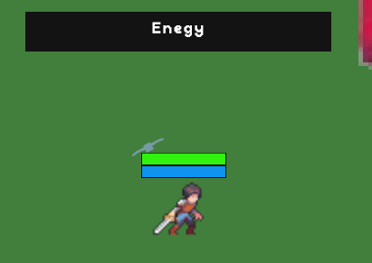

### **Enemies & Bosses:**

|  |  |  |  |
| --- | --- | --- | --- |
| **Enemies** | **Description** | **Visuals** | **Rewards** |
| **Followers** | (+10 points)  These enemies appear early in each level. They have low stats, move slowly, and are easy to defeat. They usually attack in melee or fire simple projectiles. The main character will collect Essence dropped by these enemies to meet the requirements for challenging one of Drakthor's Four Harbingers of Doom and eventually Drakthor himself. |  | Essence  Collect Essence to challenge the Harbingers of Doom. |
| **Boss - Final Protocol Terminal, the Technology Tyrant** | (+100 points)  (3 essence)  Hailing from a future where machines reign supreme, he is the ultimate destruction program, manipulating time and data to erase all obstacles. He uses replication abilities to create mini robotic entities and commands them to attack the protagonist. |  | ProtoCore  A Primal Soul Fragment. The control core of once a supreme intelligence. |
| **Boss - Gaian, the Titan Colossus** | (+125 points)  (5 essence)  The second Harbinger of Drakthor, the ancient soul of Mother Earth. He is the embodiment of mountains and the land, an eternal fortress untouched by time. Before his wrath, all creatures are mere grains of sand waiting to be crushed. |  | Titan’s Remnant  A Primal Soul Fragment. The final shard of a colossal being, infused with the primordial power of earth and stone |
| **Boss - Amunkar, the Cursed Pharaoh** | (+250 points)  (7 essence)  The third Harbinger of Drakthor, the forsaken son of the god Anubis. A pharaoh so consumed by his thirst for power that he dared to challenge the gods, only to be eternally cursed. He rules from a decayed tomb, where death is not the end but merely the beginning of servitude. |  | Pharaoh’s Wisdom (Trí tuệ của Nhà vua)  A Primal Soul Fragment. An ancient tome containing the mystical knowledge of the great Pharaohs, engraved with sacred hieroglyphs. |
| **Boss - Zephyrion, the Frost Reaper** | (+350 points)  (9 essence)  The fourth Harbinger of Drakthor, lord of blizzards and eternal night. He is the chilling wind that sweeps across the battlefield, freezing souls before their bodies can fall. **"The cold does not kill you... I do."** |  | Everfrost  A Primal Soul Fragment. A shard of ice crystallized from the souls of those who perished in eternal frost. It exudes a deadly chill, freezing anything with a mere touch. |
| **Final Boss - Drakthor the Eternal Dragon** | (+500 points)  (9 essence)  The embodiment of destruction and eternity, Drakthor is not merely a dragon—he is **time’s nightmare**. He does not rule the world out of petty ambition but to **seal and control the Primal Souls**, the divine spirits that once made him tremble.  To him, there is no place for the **chaos of lesser gods**. There is only one order—the order of **Drakthor**. |  | Heart of the Dragon  The final piece to complete the Primal Soul. The last heartbeat of the Dragon Lord. When united with the other fragments, it awakens a power beyond human comprehension. If awakened by a pure heart, it will bring peace to the world. |

## **4. Levels & Map**

* The game features a linear open world, where each area must be *cleared of all enemies* before progressing to the next stage.

|  |  |  |
| --- | --- | --- |
| **Areas** | **Visuals** | **Enemies encountered** |
| **Map 1** |  | Follower  Final Protocol Terminal, the Technology Tyrant |
| **Map 2** |  | Follower  Gaian, the Titan Colossus |
| **Map 3** |  | Follower  Amunkar, the Cursed Pharaoh |
| **Map 4** |  | Follower  Zephyrion, the Frost Reaper |
| **Map 5** |  | Follower  Drakthor, the Eternal Dragon |

## **5. Items & Equipment System**

* **Main Weapons:** Bullets, Swords
  + **Bullets & Arrows:** Ammunition for guns and bows, varying in fire rate and damage.
  + **Boss Attacks:** Includes fire, ice, stone, and curses, each causing unique effects.
  + **Magic Spells:** Energy orbs or magical strikes used for ranged attacks.
  + **Melee Weapons:** Swords and other close-combat weapons for melee engagements.

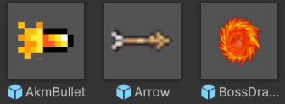

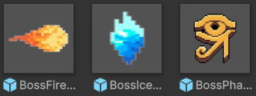

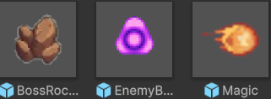

* **Support Items:**

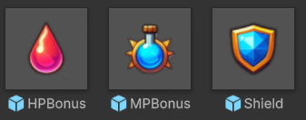

Support items provide Mana, HP, and Shield for the character.

## **6. Sound & Background Music**

* **Background Music:** Each stage has a unique track based on the theme of the map.
* **Sound Effects:** Footsteps, sword slashes, enemies’ sound effects.

## **7. Technology & Tools**

* **Game Engine:** Unity
* **Project Management:** GitHub, Google Drive
* **Graphics:** Photoshop, Unity Game Asset, Google Photos, etc.

## **8. Download Guide & Words from the Developers**

Thaloria Legacy is officially released and available for free on [Itch.io](http://itch.io)! Download now and embark on your mystical adventure. Experience, explore, and share your feedback to help us make the game even better!

[Thaloria Legacy](https://hoangxuan226.itch.io/thaloria-legacy)

——— *Developers Team*———